**ASSIGNMENT 1**

|  |  |
| --- | --- |
| Assignment Date | 15 September 2022 |
| Student Name | **Valluru Mahesh Babu** |
| Student Roll No | **110719106036** |
| Maximum Marks | **2 Marks** |

**QUESTION: Circuit design Home automation system in Tinkercad.**

**CIRCUIT DIAGRAM:**

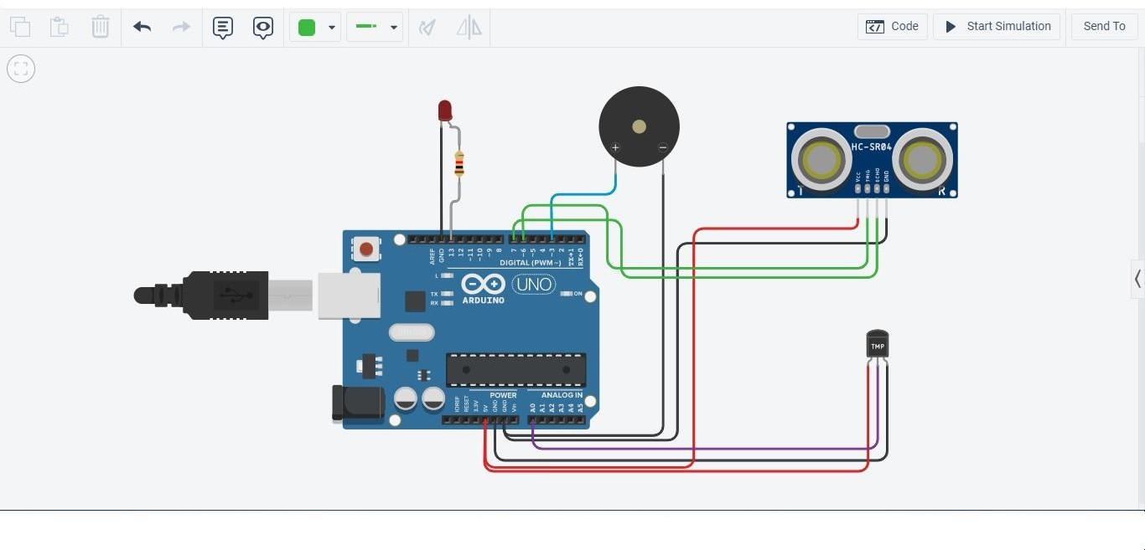

**SOURCE CODE:**

const int pingPin = 6; // Trigger Pin of Ultrasonic Sensor

const int echoPin = 7; // Echo Pin of Ultrasonic Sensor

double tempPin=A0;

void setup()

{

Serial.begin(9600); // Starting Serial Terminal

pinMode(LED_BUILTIN, OUTPUT);

pinMode(3,OUTPUT);

}

void loop()

{

long distcm,duration;

double temp; temp=analogRead(tempPin);

temp=(((temp/1024)*5)-0.5)*100;

//converting analog reading to celcius

//Turn on the buzzer when temparature increases above 70 celcius

if(temp>70)

{

digitalWrite(3, HIGH);

}

else

{

}

digitalWrite(3,LOW);

delay(1000); pinMode(pingPin, OUTPUT); digitalWrite(pingPin, LOW); delayMicroseconds(2); digitalWrite(pingPin, HIGH); delayMicroseconds(10); digitalWrite(pingPin, LOW); pinMode(echoPin, INPUT);

duration = pulseIn(echoPin, HIGH);

distcm = duration*0.0343/2;

// Turns the LED ON when the water level drops below 100cm.

if(distcm<100)

{

digitalWrite(LED_BUILTIN, HIGH);

}

else

{

}

}

digitalWrite(LED_BUILTIN, LOW);